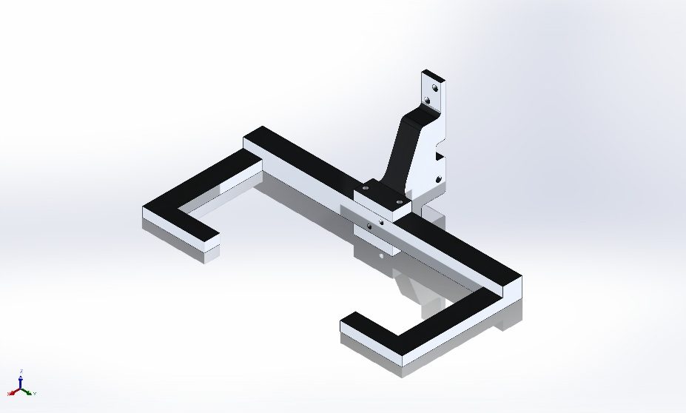 | Simulation of CM Sim  Date: Thursday, April 9, 2026  Designer: Solidworks  Study name: Static 1  Analysis type: Static  Table of Contents  Description 1  Assumptions 2  Model Information 3  Study Properties 4  Units 4  Material Properties 5  Loads and Fixtures 5  Connector Definitions 6  Interaction Information 7  Mesh information 8  Sensor Details 9  Resultant Forces 10  Beams 10  Study Results 11  Conclusion 14

Description
No Data

Assumptions

Model Information

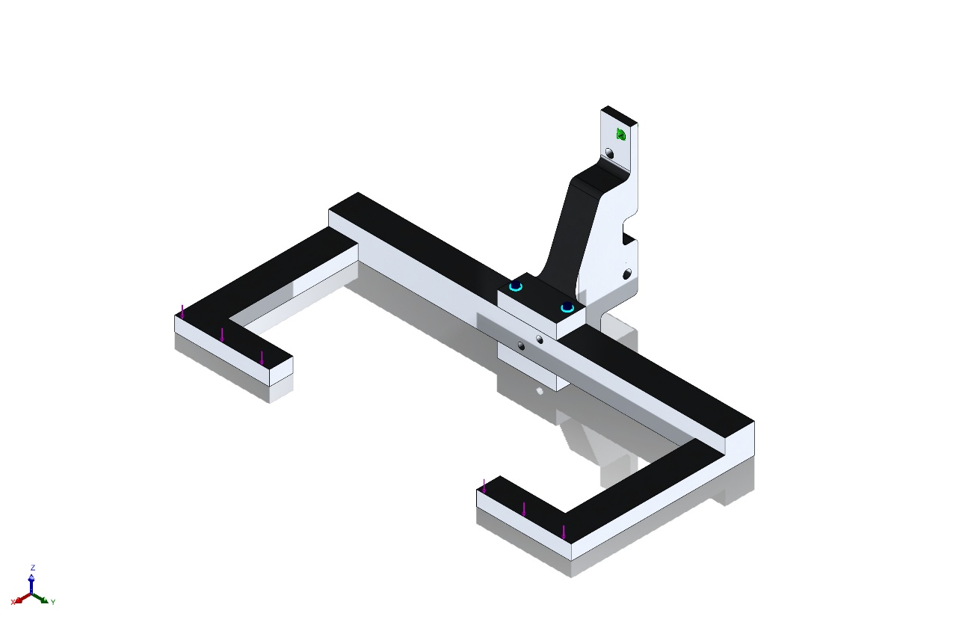
Model name: CM Sim
Current Configuration: Default
Solid Bodies
Document Name and Reference | Treated As | Volumetric Properties | Document Path/Date Modified
Thread5  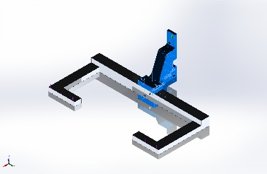 | Solid Body | Mass:0.0517438 kg  Volume:1.91644e-05 m^3  Density:2,700 kg/m^3  Weight:0.507089 N | C:\Users\Matthew Geisel\Documents\GitHub\CabinetMonkey\CM Telescoping Arm\CM Arm Carriage\CM Carriage Arm.SLDPRT  Apr 9 14:34:49 2026
Cut-Extrude3  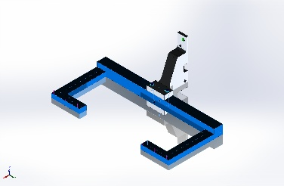 | Solid Body | Mass:0.111789 kg  Volume:4.14034e-05 m^3  Density:2,700 kg/m^3  Weight:1.09553 N | C:\Users\Matthew Geisel\Documents\GitHub\CabinetMonkey\CM Telescoping Arm\CM Arm Carriage\END EFFECTOR.SLDPRT  Mar 30 11:15:27 2026

Study Properties
Study name | Static 1
Analysis type | Static
Mesh type | Solid Mesh
Thermal Effect: | On
Thermal option | Include temperature loads
Zero strain temperature | 298 Kelvin
Include fluid pressure effects from SOLIDWORKS Flow Simulation | Off
Solver type | Automatic
Inplane Effect: | Off
Soft Spring: | Off
Inertial Relief: | Off
Incompatible bonding options | Automatic
Contact penalty stiffness scale factor | 1
Large displacement | Off
Compute free body forces | On
Friction | Off
Use Adaptive Method: | Off
Result folder | SOLIDWORKS document (C:\Users\Matthew Geisel\Documents\GitHub\CabinetMonkey\CM Telescoping Arm\CM Arm Carriage)

Units
Unit system: | SI (MKS)
Length/Displacement | mm
Temperature | Kelvin
Angular velocity | Rad/sec
Pressure/Stress | N/m^2

Material Properties
Model Reference | Properties | Components
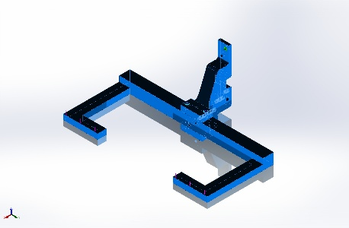 | Name: 6061-T6 (SS)  Model type: Linear Elastic Isotropic  Default failure criterion: Unknown  Yield strength: 2.75e+08 N/m^2  Tensile strength: 3.1e+08 N/m^2  Elastic modulus: 6.9e+10 N/m^2  Poisson's ratio: 0.33  Mass density: 2,700 kg/m^3  Shear modulus: 2.6e+10 N/m^2  Thermal expansion coefficient: 2.4e-05 /Kelvin | SolidBody 1(Thread5)(CM Carriage Arm-1),  SolidBody 1(Cut-Extrude3)(END EFFECTOR-1)
Curve Data:N/A

Loads and Fixtures
Fixture name | Fixture Image | Fixture Details
Fixed-3 | 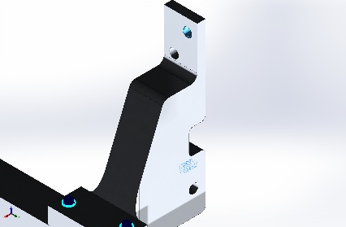 | Entities: 1 edge(s), 3 face(s)  Type: Fixed Geometry
Resultant Forces
Components | X | Y | Z | Resultant
Reaction force(N) | 8.4281e-05 | 9.95398e-06 | 100 | 100
Reaction Moment(N.m) | 0 | 0 | 0 | 0

Load name | Load Image | Load Details
Force-1 | 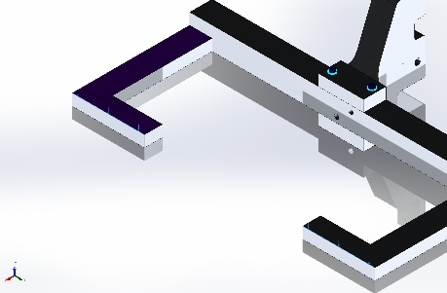 | Entities: 2 edge(s)  Reference: Face< 1 >  Type: Apply force  Values: ---, ---, -50 N

Connector Definitions

Pin/Bolt/Bearing Connector
Model Reference | Connector Details | Strength Details
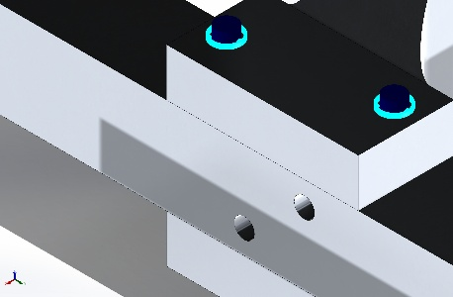  Pin Connector-1 | Entities: 3 face(s)  Type: Pin  With retaining ring (No translation): Yes  With key (No rotation): No  Connection Type: Distributed  Units: SI  Rotational stiffness value: 0 | No Data
Connector Forces Joint 1
Type | X-Component | Y-Component | Z-Component | Resultant
Axial Force (N) | -0 | -0 | 97.422 | 97.422
Shear Force (N) | -188.85 | 107.05 | 0 | 217.08
Torque (N.m) | -0 | -0 | 9.7052e-13 | 9.7052e-13
Bending moment (N.m) | 0.17332 | 0.16527 | 0 | 0.23949

Connector Forces Joint 2
Type | X-Component | Y-Component | Z-Component | Resultant
Axial Force (N) | -0 | -0 | 30.462 | 30.462
Shear Force (N) | -187.34 | 98.001 | 0 | 211.43
Torque (N.m) | -0 | -0 | 7.4923e-13 | 7.4923e-13
Bending moment (N.m) | 1.0049 | 1.8755 | 0 | 2.1277

Connector Forces Joint 3
Type | X-Component | Y-Component | Z-Component | Resultant
Axial Force (N) | 0 | 0 | -30.462 | -30.462
Shear Force (N) | 187.34 | -98.001 | 0 | 211.43
Torque (N.m) | -0 | -0 | 4.3323e-13 | 4.3323e-13
Bending moment (N.m) | -0.085886 | -0.11863 | 0 | 0.14646

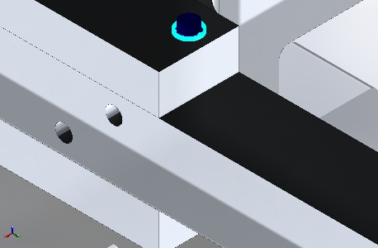  Pin Connector-2 | Entities: 3 face(s)  Type: Pin  With retaining ring (No translation): Yes  With key (No rotation): No  Connection Type: Distributed  Units: SI  Rotational stiffness value: 0 | No Data
Connector Forces Joint 1
Type | X-Component | Y-Component | Z-Component | Resultant
Axial Force (N) | -0 | -0 | 94.61 | 94.61
Shear Force (N) | -179.4 | -118.71 | 0 | 215.12
Torque (N.m) | -0 | -0 | 1.5915e-13 | 1.5915e-13
Bending moment (N.m) | -0.16195 | -0.033547 | 0 | 0.16539

Connector Forces Joint 2
Type | X-Component | Y-Component | Z-Component | Resultant
Axial Force (N) | -0 | -0 | 61.569 | 61.569
Shear Force (N) | -180.91 | -109.67 | 0 | 211.55
Torque (N.m) | -0 | -0 | 7.5095e-13 | 7.5095e-13
Bending moment (N.m) | -1.2066 | 1.8841 | 0 | 2.2373

Connector Forces Joint 3
Type | X-Component | Y-Component | Z-Component | Resultant
Axial Force (N) | 0 | 0 | -61.569 | -61.569
Shear Force (N) | 180.91 | 109.67 | 0 | 211.55
Torque (N.m) | -0 | -0 | 1.456e-12 | 1.456e-12
Bending moment (N.m) | 0.17585 | -0.18372 | 0 | 0.25431

Interaction Information
No Data

Mesh information
Mesh type | Solid Mesh
Mesher Used: | Blended curvature-based mesh
Jacobian points for High quality mesh | 16 Points
Maximum element size | 0.309327 in
Minimum element size | 0.0376657 in
Mesh Quality | High
Remesh failed parts independently | Off
Reuse mesh for identical parts in an assembly (Blended curvature-based mesher only) | Off

Mesh information - Details
Total Nodes | 66478
Total Elements | 42304
Maximum Aspect Ratio | 23.258
% of elements with Aspect Ratio < 3 | 83.4
Percentage of elements with Aspect Ratio > 10 | 4.25
Percentage of distorted elements | 0
Time to complete mesh(hh;mm;ss): | 00:00:17
Computer name:

Mesh Quality Plots
Name | Type | Min | Max
Quality1 | Mesh | - | -
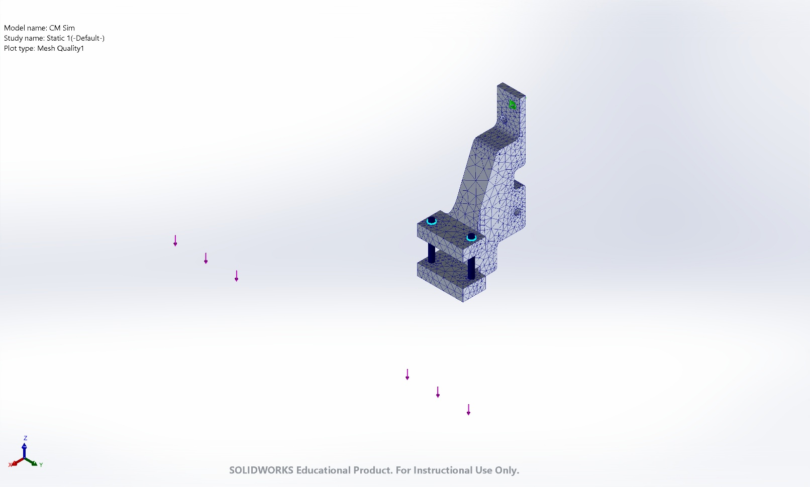
CM Sim-Static 1-Quality-Quality1

Sensor Details
No Data

Resultant Forces

Reaction forces
Selection set | Units | Sum X | Sum Y | Sum Z | Resultant
Entire Model | N | 8.4281e-05 | 9.95398e-06 | 100 | 100

Reaction Moments
Selection set | Units | Sum X | Sum Y | Sum Z | Resultant
Entire Model | N.m | 0 | 0 | 0 | 0

Free body forces
Selection set | Units | Sum X | Sum Y | Sum Z | Resultant
Entire Model | N | 0.000191092 | 8.34465e-07 | 0.00682533 | 0.006828

Free body moments
Selection set | Units | Sum X | Sum Y | Sum Z | Resultant
Entire Model | N.m | 0 | 0 | 0 | 1e-33

Beams
No Data

Study Results

Name | Type | Min | Max
Stress1 | VON: von Mises Stress | 1.473e+04N/m^2  Node: 93 | 6.151e+07N/m^2  Node: 48244
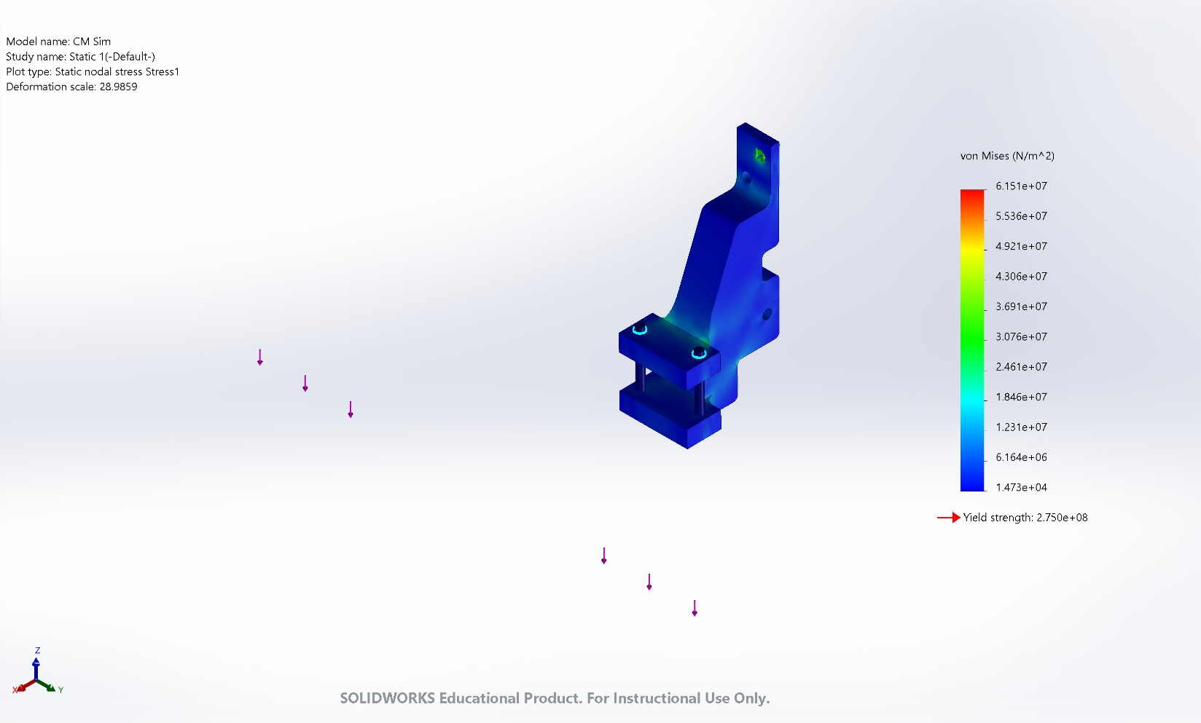
CM Sim-Static 1-Stress-Stress1

Name | Type | Min | Max
Displacement1 | URES: Resultant Displacement | 0.000e+00mm  Node: 67 | 5.889e-01mm  Node: 52649
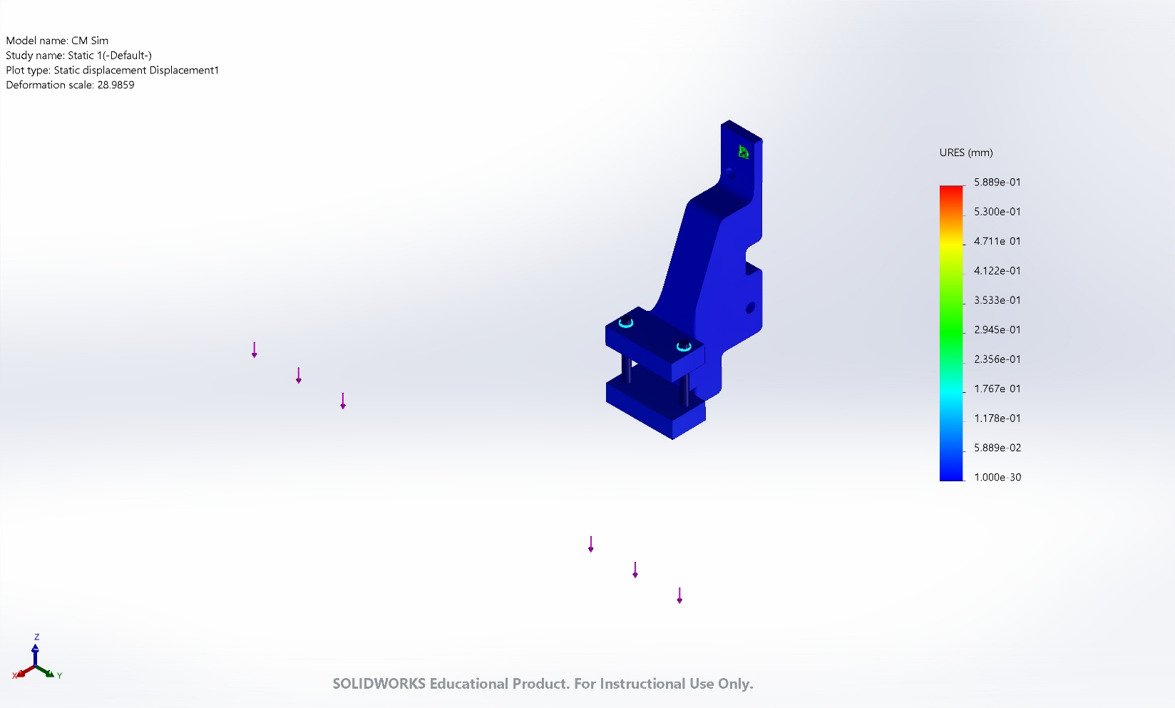
CM Sim-Static 1-Displacement-Displacement1

Name | Type | Min | Max
Strain1 | ESTRN: Equivalent Strain | 1.405e-07  Element: 28233 | 5.059e-04  Element: 16568
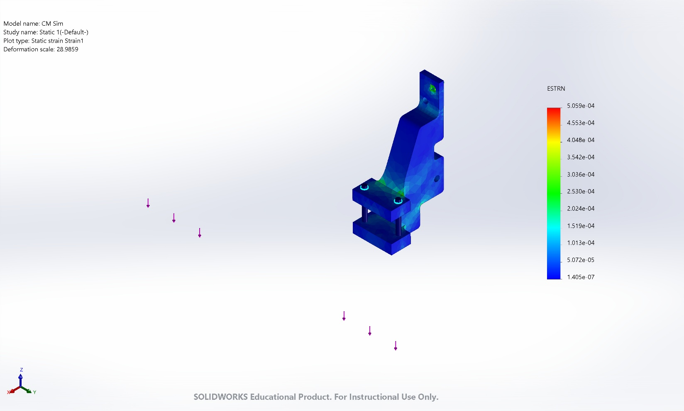
CM Sim-Static 1-Strain-Strain1

Name | Type
Displacement1{1} | Deformed shape
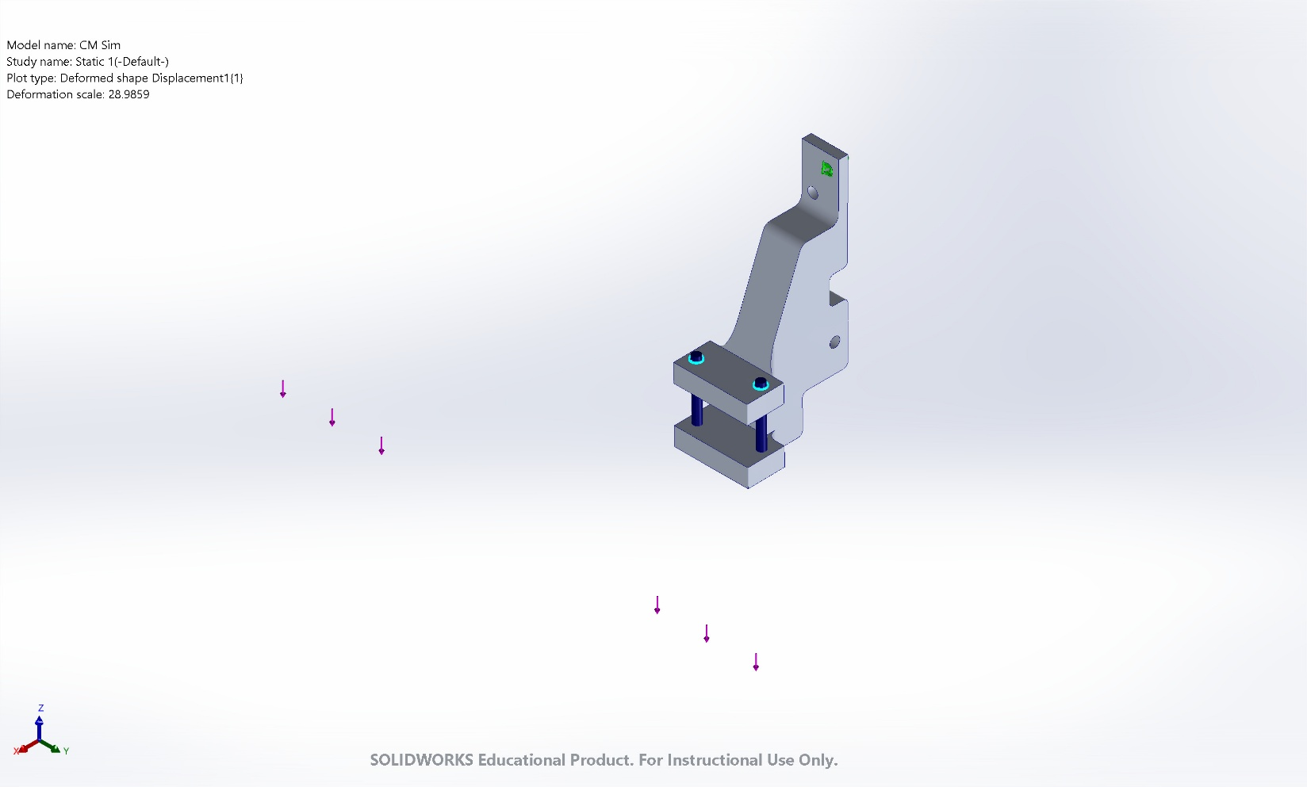
CM Sim-Static 1-Displacement-Displacement1{1}

Conclusion

